Comparing proteins of different sizes

You have a 30 kDa protein (protein A) at a concentration of 5 mg/mL and a 90 kDa protein (protein B) at a concentration of 10 mg/mL.

Reminder: kDa stands for kilodalton. 1 kilodalton = 1000 Daltons. And 1 Dalton = 1 g/mol. So, 1 kDa = 1000 g/mol.

Without doing any formal calculations, just thinking it through, which of these solutions has a higher molar concentration (which has more protein copies?)

Protein B is 3 times more massive than protein A (90/30=3)
So it will take 3 times as much mass of protein B to equal the mass of protein A.
Our protein B solution only has 2 times as much mass-wise. So protein A will have a higher molar concentration.

Now do the formal math:

Remember: you need to convert kDa to Da so you’re working with g/mol instead of kg/mol

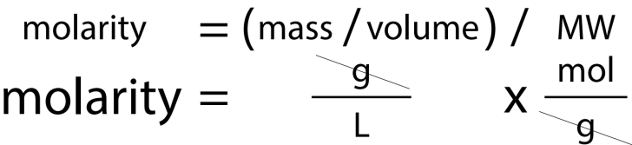

What is the molarity of the 30 kDa protein (protein A) solution?

0.000167 M = 1.67 x 10^-4 M

If you recognize 5 mg/mL is equal to 5 g/L

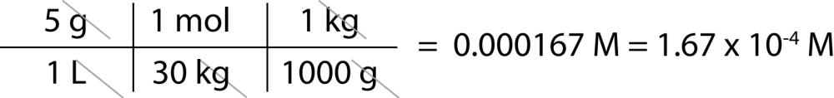

Since we’re in the metric range between 10^-6 and 10^-3, we’re between μ and m, so our “cleanest” unit will be μM

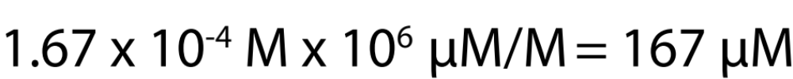
  - x 10^-4 M x 10^6 μM/M = 1.11 x 10^2 μM = 167 μM

What is the molarity of the 90 kDa protein (protein B) solution?

0.000111 M = 1.11 x 10^-4 M

If you recognize 10 mg/mL is equal to 10 g/L

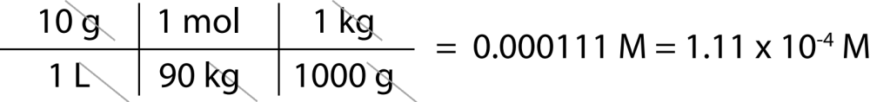

Since we’re in the metric range between 10^-6 and 10^-3, we’re between μ and m, so our “cleanest” unit will be μM

1.11 x 10^-4 M x 10^6 μM/M = 1.11 x 10^2 μM = 111 μM

